

American International University-Bangladesh (AIUB)  
 **Department of Computer Science**  
 **Faculty of Science & Technology (FST)**

**TREE PLANTATION CHARITY MANAGEMENT SYSTEM**

A Software Engineering Project Submitted By

|  |  |  |  |  |
| --- | --- | --- | --- | --- |
| **Semester: Spring 23-24** | | **Section: D** | **Group Number: 04** | |
| SN | Student Name | Student ID | Contribution (CO3+CO4) | Individual  Marks |
| 1 | MD. Jobaer Hossain | 22-47116-1 | 25% |  |
| 2 | Samia Sharmin Dola | 22-47126-1 | 25% |  |
| 3 | Rifah Sanzida | 22-47154-1 | 25% |  |
| 4 | Shayan Abrar | 22-47156-1 | 25% |  |
|  |  |  |  |  |

The project will be Evaluated for the following Course Outcomes

|  |  |  |
| --- | --- | --- |
| **CO3:** *Select* appropriate software engineering models, project management roles and their associated skills for the complex software engineering project and evaluate the sustainability of developed software, taking into consideration the societal and environmental aspects | Total Marks | |
|  | |
| Appropriate Process Model Selection and Argumentation with Evidence | [5 Marks] |  |
| Evidence of Argumentation regarding process model selection | [5Marks] |  |
| Evaluate the sustainability of the developed software in terms of both society and the environment (Impact identification) | [5Marks] |  |
| Submission, Defense, Completeness, Spelling, grammar and Organization of the Project report | [5Marks] |  |
| **CO4:** *Develop* project management plan to manage software engineering projects following the principles of engineering management and economic decision process | Total Marks | |
|  | |
| Develop the project plan, its components of the proposed software products | [5Marks] |  |
| Identify all the activities/tasks related to project management and categorize them within the WBS structure. Perform detailed effort estimation correspond with the WBS and schedule the activities with resources | [5Marks] |  |
| Identify all the potential risks in the specific project and prioritizing/categorizing those to overcome the risk factors. | [5Marks] |  |

Description of Student’s Contribution in the Project work

|  |
| --- |
| Student Name: MD. Jobaer Hossain  Student ID: 22-47116-1  Contribution in Percentage (%):25%  Contribution in the Project:   * Contribution Description : Gantt chart, Project management   Contribution Description : Project report, sequence diagram      ________jobaer___________  Signature of the Student |
| Student Name: Samia Sharmin Dola  Student ID: 22-47126-1  Contribution in Percentage (%):25%  Contribution in the Project:   * Contribution Description : Use-case diagram, Activity Diagram * Contribution Description : Project planning, Project Risk       ________samia___________  Signature of the Student |
| Student Name: Rifah Sanzida  Student ID: 22-47154-1  Contribution in Percentage (%):25%  Contribution in the Project:   * Contribution Description: Class Diagram, WBS * Contribution Description: Deployment/Package Diagram, Project Requirements       _________rifah__________  Signature of the Student |
| Student Name: Shayan Abrar  Student ID: 22-47156-1  Contribution in Percentage (%):25%  Contribution in the Project:   * Contribution Description: Prototype design with basic HTML and TAILWIND CSS for web view and responsive mobile application view. * Contribution Description: Architectural diagram, Test & SQA plan, Maintenance.       ________abrar___________  Signature of the Student |
| Student Name:  Student ID:  Contribution in Percentage (%):  Contribution in the Project:   * Contribution Description 1 * Contribution Description 2       ___________________  Signature of the Student |

# PROJECT PROPOSAL

## Background to the Problem

* Write the background description that helps putting your project into the right context of a problem domain and gives everyone involved a common view of the project.
* What is the root cause of this problem? Why this problem is so important to consider?

## Solution to the Problem

* Describe what is your project/thesis objective? What solutions are you going to provide to solve the above-mentioned problems?
* What are the solutions you are going to propose to deal with the problem? why is this solution is particularly appropriate to solve the problem? Is the solution feasible to the meet the business objective?
* Describe the basic functionalities of your proposed solution that makes the best use of state‐of‐art technology and produced a significant result that is likely to have a major impact on societal, health, safety, legal and cultural issues. Provide a deep insight that demonstrate and preset a creative solution to the real‐life problem.
* Describe the target group of users of your solution? And how they will be benefited by your proposed solution to the problem?
* Describe the contribution of your project to the development of scientific results that is identified and well documented.
* Provide a literature review on what are the other studies that have discussed the same topic of yours in the literature and explain how your study has utilized and extended the problems of existing studies.
* Provide a description of all the existing studies presented in the problem area. What are the existing software solutions (for project) are available to solve the aforementioned problems?
* What are the existing software solutions are available to solve the aforementioned problem? And how your proposed solution is going to extend them in providing more benefits to the users?

# SOFTWARE DEVELOPMENT LIFE CYCLE

## Process Model

* Provide an analysis regarding the nature and environment of the software that you are going to develop and select the best suitable method(s) to develop the software.
* Present your arguments based on your analysis about why your selected method(s) is the best choice among all other methods to develop your proposed software.
* Presents sufficient amount of evidence to support argument for your model selection in developing your proposed solution.

## Project Role Identification and Responsibilities

* Identify all the roles/stakeholder in the software/project management activities in software development.
* Describes the responsibilities of the role in the software development.

**Text Format:**

* Style: Times New Roman
* Size: 12
* Space: 1.0
* Alignment: Justify
* Length: Maximum 6 pages (including cover page)

## Rubric for Project Assessment (CO3)

|  |  |  |  |  |  |
| --- | --- | --- | --- | --- | --- |
| Criteria | Marks distribution (Max 4X5= 20) | | | | Acquired  Marks |
| **Missing/ Incorrect (0-1)** | **Inadequate (2)** | **Satisfactory (3-4)** | **Excellent (5)** |
| Selection of Software Engineering Models | Does not articulate a position or argument of choosing appropriate model. Does not present any evidence to support the arguments for the choice of the model. | Articulates a position or argument for choosing models that is unfocused or ambiguous. Presents incomplete/vague evidence to support argument for model choice. | Articulates a position or argument of choosing models that is limited in scope. Does not present enough evidence to support the argument for the choice of the model | Clearly articulates a position or argument for the choosing software engineering models. Presents sufficient evidence to support argument for the model selection |  |
| Role identification and Responsibility Allocation | The project has poor project management plans for identifying roles and assigning the responsibilities | Identify few roles in the project management where some of the roles are left alone with any project responsibilities | Identify most of the roles in the project management and assign their responsibilities | Well planned project with proper role identification and responsibility allocation in the project management activities |  |
| Impact identification | Student vaguely discuss the impact of societal, health, safety, legal, cultural, or environmental issues in their project | Student provided with partial relevance to the impact of societal, health, safety, legal, cultural, or environmental issues in their project | Student fairly provided the analysis to the impact of societal, health, safety, legal, cultural, or environmental issues in their project | Student comprehensively provided the analysis to the impact of societal, health, safety, legal, cultural, or environmental issues in their project |  |
| Formatting and Submission | Project report is not complete and Several errors in spelling and grammar. Present a Confusing organization of concepts, supporting arguments, and  real-life example. Sentences rambling, and details are repeated. | Some errors in spelling and grammar. Some problems  of organizing the answer in a logical order of defining, elaborating, and providing real-life examples. | Few errors in spelling and grammar. Presents most of the details in a logical flow of  organization in  definition,  details, and  example. | Project report is complete and No errors in spelling and grammar. Consistently  presents a logical  and effective  organization of definition,  details, and real-life example of  the topic. |  |
| Acquired marks: | | | | |  |
| CO Pass / Fail: | | | | |  |

## Rubric for Project Assessment (CO4)

|  |  |  |  |  |  |
| --- | --- | --- | --- | --- | --- |
| Marking Criteria | Marks Distribution (Maximum 3X5=15) | | | | Acquired Marks |
| **Missing/ Incorrect (0-1)** | **Inadequate (2)** | **Satisfactory (3-4)** | **Excellent (5)** |
|  |  |  |  |  |  |
| Project Planning | Missing or incorrect project plan; | Insufficient project plan provided: project team, project tasks, goals etc. stated poorly. | Sufficient information provided : project team members, their tasks, project plan discussed in details. | Thorough and relevant project plan is provided; project plan is clear and easy to follow. |  |
| Effort Estimation and Scheduling | Missing or incorrect effort estimation or schedules based on available project resources | Insufficient or poorly stated effort estimation or schedules based on available project resources | Correct or sufficient technique used for effort estimation or schedules based on available project resources | Project estimation was described using proper effort estimation or schedules based on available project resources |  |
| Risk Management | Risk analysis activities were missing or inappropriate for the specific project: unidentified risks or wrongly categorized risks or not prioritized properly. | Risks are partially identified(insufficient) and not properly categorized or not prioritized properly. | Sufficient and critical risks are identified(insufficient) and properly categorized but not prioritized properly. | Sufficient and appropiate risks are identified, analyzed, and properly categorized or prioritized. |  |
| Acquired Marks: | | | | |  |
| CO Pass / Fail: | | | | |  |

**Project description**

The Ever Green Foundation Software is an environmental organization that is fully dedicated to bringing about positive change in our natural world. We are committed to promoting sustainability and biodiversity through various strategic initiatives, including tree planting, habitat restoration, and community education. Our online platform serves as a central hub for individuals who are passionate about environmental conservation to actively engage and make contributions. Visitors to our platform can easily track their impact by accessing metrics such as the number of trees planted, carbon emissions offset, and habitat enhancement achieved through their support. Furthermore, our platform provides valuable insights into ongoing projects, allowing users to stay informed about current environmental efforts and explore opportunities for involvement. In addition, It features moving testimonies from recipients that elegantly demonstrate the concrete results of group effort.

**Problem Statement**

Our planet is struggle with intense environmental challenges that threaten the liveliness of our ecosystems, the diversity of species, and the well-being of human societies. Among these, deforestation not only leads to a sharp loss of biodiversity but also disrupts climate regulation, contributing to global warming. Urbanization and industrial activities exacerbate carbon emissions, enhancing the greenhouse effect and leading to climate change. These activities also degrade natural habitats, putting numerous species at risk of extinction. A significant barrier to addressing these issues is the lack of public awareness about the importance of environmental protection and the impact of human actions on the health of our planet. Additionally, environmental organizations often struggle with inadequate resources, such as funding and manpower, limiting their ability to effectively tackle these issues. Engaging communities in protecting efforts is further challenged by differing priorities, lack of education, and socio-economic factors, underscoring the need for a detailed solution that addresses these multifaceted challenges. Some of the main challenges are:

* **Deforestation**: Many areas around the world are experiencing deforestation, leading to loss of biodiversity, habitat destruction, and adverse effects on climate stability.
* **Carbon Emissions:** Human activities such as transportation and industrial processes release large amounts of carbon dioxide into the atmosphere, contributing to global warming and climate change.
* **Habitat Degradation:** Urbanization and industrialization often result in the degradation of natural habitats, threatening the survival of various plant and animal species.
* **Lack of Awareness**: Many people are unaware of the importance of environmental conservation and the impact of their actions on the planet's health.
* **Limited Resources:** Environmental organizations often face challenges in securing adequate resources, including funding and manpower, to address conservation issues effectively.
* **Community Engagement:** Engaging communities in environmental conservation efforts can be challenging due to differing priorities, lack of education, and socio-economic factors.

**Proposed Solution**

To counteract these pressing environmental issues, our platform will serve as a beacon for education, collaboration, and proactive action. Our goal is to debunk the myths around environmental issues by providing engaging facts that clarifies the effects of ecosystem loss, carbon emissions, and deforestation. Our platform will feature:

* **Raising Awareness:** Our software will provide easy-to-understand information about environmental issues like deforestation, carbon emissions, and habitat degradation. Through engaging content, we aim to educate visitors about the importance of conservation efforts.
* **Tree Planting Initiatives:** We will facilitate tree planting events and campaigns in collaboration with local communities. By encouraging individuals to contribute to tree planting projects, we aim to combat deforestation and promote biodiversity.
* **Carbon Offset Programs**: Our platform will promote carbon offset programs where users can calculate their carbon footprint and contribute to projects that reduce greenhouse gas emissions, such as reforestation and renewable energy initiatives.
* **Habitat Restoration:** Partnering with environmental organizations, we are restoring damaged ecosystems and providing habitat for threatened species. we are going to support habitat restoration initiatives.
* **Interactive Features:** Through interactive features like forums and success stories, we will foster community engagement and encourage active participation in environmental conservation efforts.
* **Resource Mobilization:** We will facilitate fundraising campaigns and donation drives to support environmental organizations and initiatives, ensuring they have the resources needed to carry out their conservation activities effectively.

We chose the Scrum framework for its adaptability, emphasis on collaboration, and capability to manage complex projects with shifting requirements. Unlike traditional models, Scrum allows for rapid iteration and flexibility, essential for a project responding to the dynamic field of environmental conservation. Its structured yet flexible approach enables our team to regularly check and adapt to stakeholders' needs, technological advancements, and new environmental data. This agility ensures that our platform remains to the purpose and effective in its mission, making Scrum the ideal methodology for our project.

**Process Model**

**Scrum Roles:**

* **Product Owner:** Responsible for defining the project vision, prioritizing features, and ensuring that the product backlog is aligned with stakeholder needs. The product owner will represent the interests of the users and stakeholders throughout the project.
* **Scrum Master:** Facilitates the Scrum process, removes hinderance, and ensures that the Scrum team stick to Scrum principles and practices. The Scrum master will coach the team and help them optimize their productivity.
* **Development Team:** Comprised of cross-functional members responsible for delivering potentially shippable increments of the product. The development team collaborates closely to design, develop, test, and deploy features.

**Scrum Artifacts:**

* **Product Backlog:** A prioritized list of features, enhancements, and bug fixes maintained by the product owner. The product backlog serves as the single source of requirements for the Scrum team.
* **Sprint Backlog:** A subset of items from the product backlog selected for implementation during a sprint. The sprint backlog is owned by the development team and contains the tasks required to complete the selected backlog items.
* **Increment:** The sum of all the product backlog items completed during a sprint, potentially shippable and usable by stakeholders.

**Scrum Events:**

* **Sprint Planning**: At the beginning of each sprint, the product owner and development team collaborate to select backlog items for the sprint backlog. They discuss the scope, objectives, and acceptance criteria for each item.
* **Daily Standup:** A short daily meeting where the development team shares progress, plans for the day, and any hinderance they're facing. The Scrum master facilitates the standup to ensure it stays focused and timeboxed.
* **Sprint Review**: At the end of each sprint, the development team demonstrates the completed increment to the product owner and stakeholders. They gather feedback and discuss potential adaptations to the product backlog.
* **Sprint Retrospective:** A meeting held after the sprint review where the development team reflects on their process, identifies strengths and areas for improvement, and agrees on action items to enhance future sprints.

**Scrum Implementation in Our Project:**

* **Product Backlog Refinement:** The product owner continuously refines the product backlog based on feedback from stakeholders and market research.
* **Sprint Planning:** At the beginning of each sprint, the development team collaborates with the product owner to select backlog items and define sprint goals.
* **Daily Standup:** The development team conducts daily standup meetings to synchronize their activities, discuss progress, and identify any obstacles.
* **Sprint Review and Retrospective:** At the end of each sprint, the team holds sprint review and retrospective meetings to gather feedback, celebrate achievements, and plan improvements for the next sprint.
* **Adaptation:** Throughout the project, the Scrum team embraces change and adapts to evolving requirements, market conditions, and stakeholder needs.

By utilizing the Scrum framework, our project aims to promote transparency, collaboration, and adaptability, ultimately delivering a high-quality environmental conservation software that meets the needs of our users and stakeholders.

**WBS**

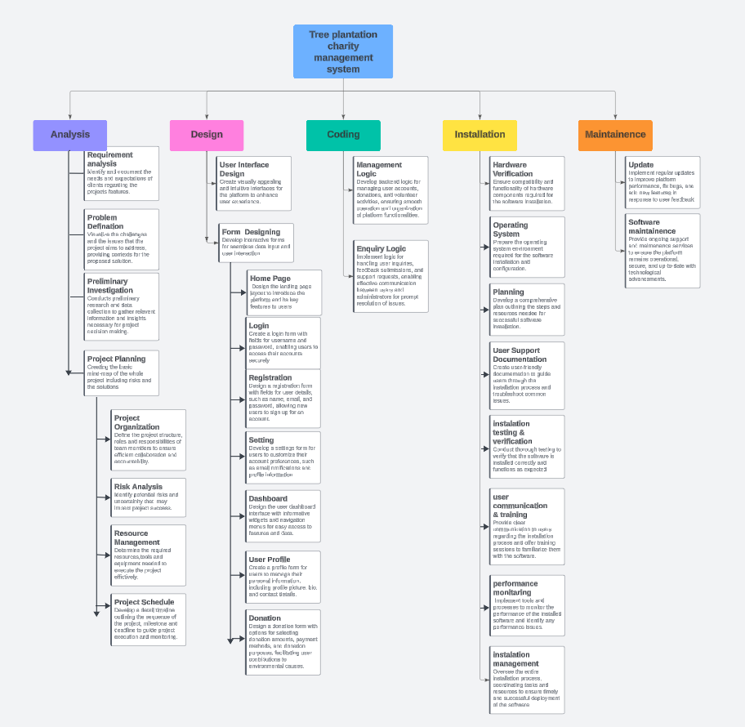

**Gantt chart -**

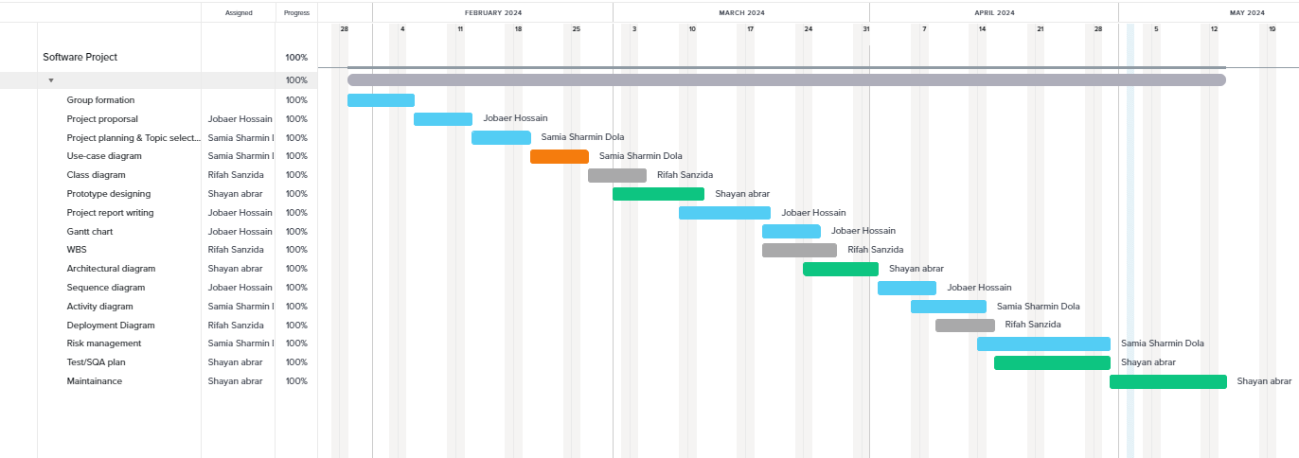

**Project Risks –**

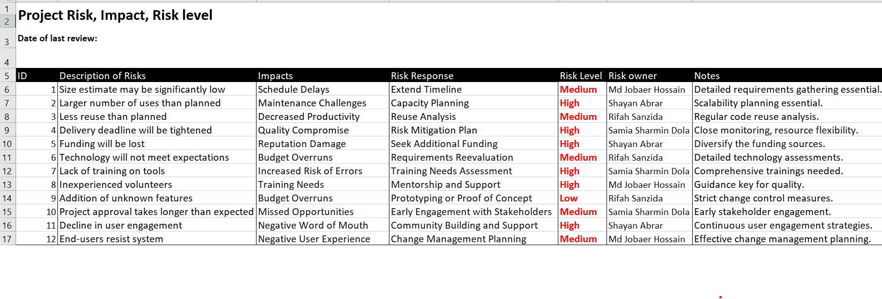

**Technical Challenges:**

**Description:** Developing a website with complex features such as donation processing, user authentication, and interactive maps may pose technical hurdles.

**Impact:** Delays in feature implementation, decreased product quality, and potential budget overruns.

**Mitigation:**

* **Feasibility Studies:** Before development, conduct comprehensive assessments to ensure technical feasibility, identifying potential hurdles in early stages.
* **Development Buffer:** Allocate additional time for Research and Development to account for unexpected technical challenges, ensuring timelines remain realistic.

**Resource Constraints:**

**Description:** Limited availability of skilled team members, including developers, designers, and testers, could hinder project progress.

**Impact:** Slow development pace, increased workload on existing team members, and compromised product quality.

**Mitigation:**

* **Skills Development:** Offer regular training sessions to upskill existing team members, maximizing resource efficiency.
* **Task Outsourcing:** Evaluate tasks for outsourcing potential, particularly for specialized skills not present within the team, to maintain project momentum.

**Project Scope Expansion:**

**Description:** Continuous addition of new features or changes to existing requirements beyond the project's initial scope may occur.

**Impact:** Extended project timelines, increased development costs, and potential conflicts with stakeholder expectations.

**Mitigation:**

* **Feature Prioritization:** Utilize a rigorous feature prioritization process, ensuring additions align with core project goals and user needs.
* **Change Control Process:** Implement a formal change control process, requiring stakeholder consensus for scope adjustments to prevent project bloat and focus drift.  
    
  **Security Vulnerabilities:**

**Description:** Inadequate attention to cybersecurity measures may expose the software to risks such as data breaches, unauthorized access, or malware attacks.

**Impact:** Compromised user data, damage to organizational reputation, and legal outcome.

**Mitigation:** Implement strong security protocols, conduct regular security audits and penetration testing, and stick to industry best practices for data protection.

**User Adoption Challenges:**

**Description:** Low user engagement or adoption rates due to usability issues, lack of awareness, or ineffective marketing strategies.

**Impact:** Reduced website traffic, diminished donation contributions, and failure to achieve project objectives.

**Mitigation:** Prioritize user experience (UX) design, gather user feedback through usability testing, and implement targeted marketing campaigns to promote the website.

**External Dependencies:**

**Description:** Reliance on third-party services, APIs, or external vendors for critical functionalities such as payment processing or mapping services.

**Impact:** Delays or disruptions caused by third-party downtime, service outages, or changes in service terms.

**Mitigation:** Identify and evaluate dependencies early in the project, establish contingency plans, and maintain open communication channels with external providers.

**Project requirements**

**Main Webpage:**

**Homepage:** The homepage serves as the entry point to the EverGreen Foundation's digital presence. It presents visitors with a visually appealing overview of the foundation's core mission, ongoing projects, and the positive impact it has achieved.

**Navigation Menu:** A user-friendly navigation menu is prominently displayed, allowing visitors to effortlessly explore different sections of the website. This includes options to learn more about the foundation (About Us), view current projects and initiatives (Projects), get in touch (Contact), and support the cause through donations (Donation).

**Donation Section:** Positioned strategically on the homepage, the donation section offers visitors a convenient and secure platform to contribute to the foundation's efforts. It provides clear information on how donations are used and encourages visitors to support environmental conservation.

**Impact Stories:** Engaging stories and testimonials from beneficiaries are showcased on the homepage, illustrating the real-world impact of the foundation's work. These stories serve to inspire visitors and reinforce the significance of their potential contributions, whether through donations or volunteering.  
  
  
**Login/Logout:**

**Who Can Access:** Access to the login/logout functionality is available to all users of the website, including visitors, donors, volunteers, and administrators.

**User Authentication:** To access personalized features such as profile management and donation tracking, users are required to log in using their credentials (e.g., username/email and password).

**Session Management:** Upon successful login, a session is initiated, allowing users to navigate different sections of the website without having to reauthenticate their identity.

**Logout:** Users can log out of their accounts at any time by clicking on the logout button, which terminates the active session and redirects them to the homepage or login page.  
  
  
**User Dashboard:**

**Profile Management:** Within the user dashboard, individuals can create and manage their personal profiles. This includes updating contact information, preferences, and viewing their donation history. The profile management feature ensures that users have control over their engagement with the foundation.

**Donation Tracking:** Users can access a comprehensive overview of their donation history, including details such as the amount donated, the specific projects supported, and the resulting impact achieved. This transparent tracking system fosters trust and accountability between the foundation and its donors.

**Ordering Trees for Planting:** Within the user dashboard, individuals have the unique opportunity to contribute directly to environmental conservation efforts by ordering trees for planting in their area. This feature empowers users to take solid action towards greening their communities and offsetting carbon emissions.

**Communication Channels:** To facilitate seamless communication, the user dashboard provides various channels for users to engage with foundation administrators. Whether seeking assistance, providing feedback, or simply reaching out with inquiries, users can utilize messaging systems or support tickets for efficient communication.  
  
  
**Donor Dashboard:**

**Donation Management:** Donors are empowered to manage their contributions effectively through the donor dashboard. They can review and manage recurring donations, initiate one-time contributions, and access detailed reports on their donation history. This feature streamlines the donation process and enhances donor engagement.

**Impact Reports:** Detailed impact reports are available to donors, highlighting the tangible outcomes of their contributions. From the number of trees planted to the amount of carbon offset achieved, donors gain insights into the positive change their donations have enabled, fostering a sense of pride and fulfillment.

**Recognition:** The donor dashboard includes features for recognizing and appreciating donors for their invaluable support. Whether through digital certificates, virtual badges, or personalized acknowledgment letters, donors are celebrated for their generosity and commitment to environmental conservation.

**Feedback Mechanism:** Donor’s receivers are encouraged to provide feedback to the donor dashboard, enabling them to share their thoughts, suggestions, and overall experiences. This feedback mechanism helps the foundation continuously improve its donor engagement strategies and tailor future projects to align with donor preferences and also helps to encourage the donor to donate.  
  
  
**Volunteer Dashboard:**

**Event Registration:** Volunteers can easily explore and register for upcoming events and activities through the volunteer dashboard. From tree planting initiatives to community clean-up efforts, volunteers have access to a comprehensive list of opportunities, allowing them to contribute meaningfully to the foundation's mission.

**Training Resources:** The volunteer dashboard provides access to many training materials and resources to equip volunteers with the necessary knowledge and skills for their roles. These resources may include instructional guides, videos, and educational materials tailored to specific volunteer tasks and responsibilities.

**Task Assignment:** Volunteers receive clear task assignments and responsibilities through the dashboard, ensuring efficient project execution and coordination. Assignments may vary based on volunteer skills, availability, and preferences, allowing for effective utilization of volunteer resources.

**Performance Tracking:** Volunteer performance and contributions are tracked systematically within the dashboard, allowing administrators to recognize and reward top performers. Metrics such as volunteer hours, tasks completed, and impact achieved provide valuable insights into volunteer engagement and effectiveness.  
  
  
**Admin Dashboard:**

**User Management:** Administrators have full control over user management functionalities, including user registration, authentication, and account permissions. The admin dashboard allows for seamless management of user accounts, ensuring a secure and personalized user experience.

**Content Management:** The admin dashboard empowers administrators to update and manage website content effortlessly. From text and images to videos and news updates, administrators can keep the website dynamic and engaging, reflecting the foundation's latest initiatives and achievements.

**Donation Monitoring:** Administrators can monitor donation activities in real-time through the admin dashboard. This includes tracking incoming donations, analyzing donor demographics, and evaluating fundraising campaign performance to inform strategic decision-making and resource allocation.

**Volunteer Coordination:** The admin dashboard serves as a centralized hub for volunteer coordination, facilitating event planning, volunteer recruitment, training, and coordination efforts. Administrators can efficiently manage volunteer resources and ensure the successful execution of various projects and initiatives.

**Non-functional requirements**

• Security: The system maintains the privacy of user information.

• Ease of use: The system is very user friendly.

• Reliability: Our system will run without a failure for a given period under predefined conditions

• Availability: Our system is accessible for all type of user.

• Performance: The system returns the results quickly.

**Use-Case diagram**

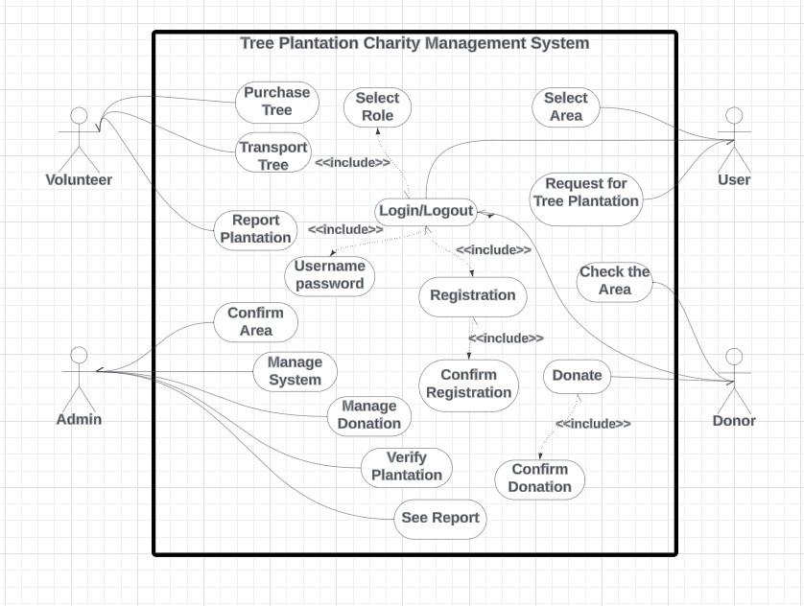

**Prototype design**

**For Desktop**

Login-

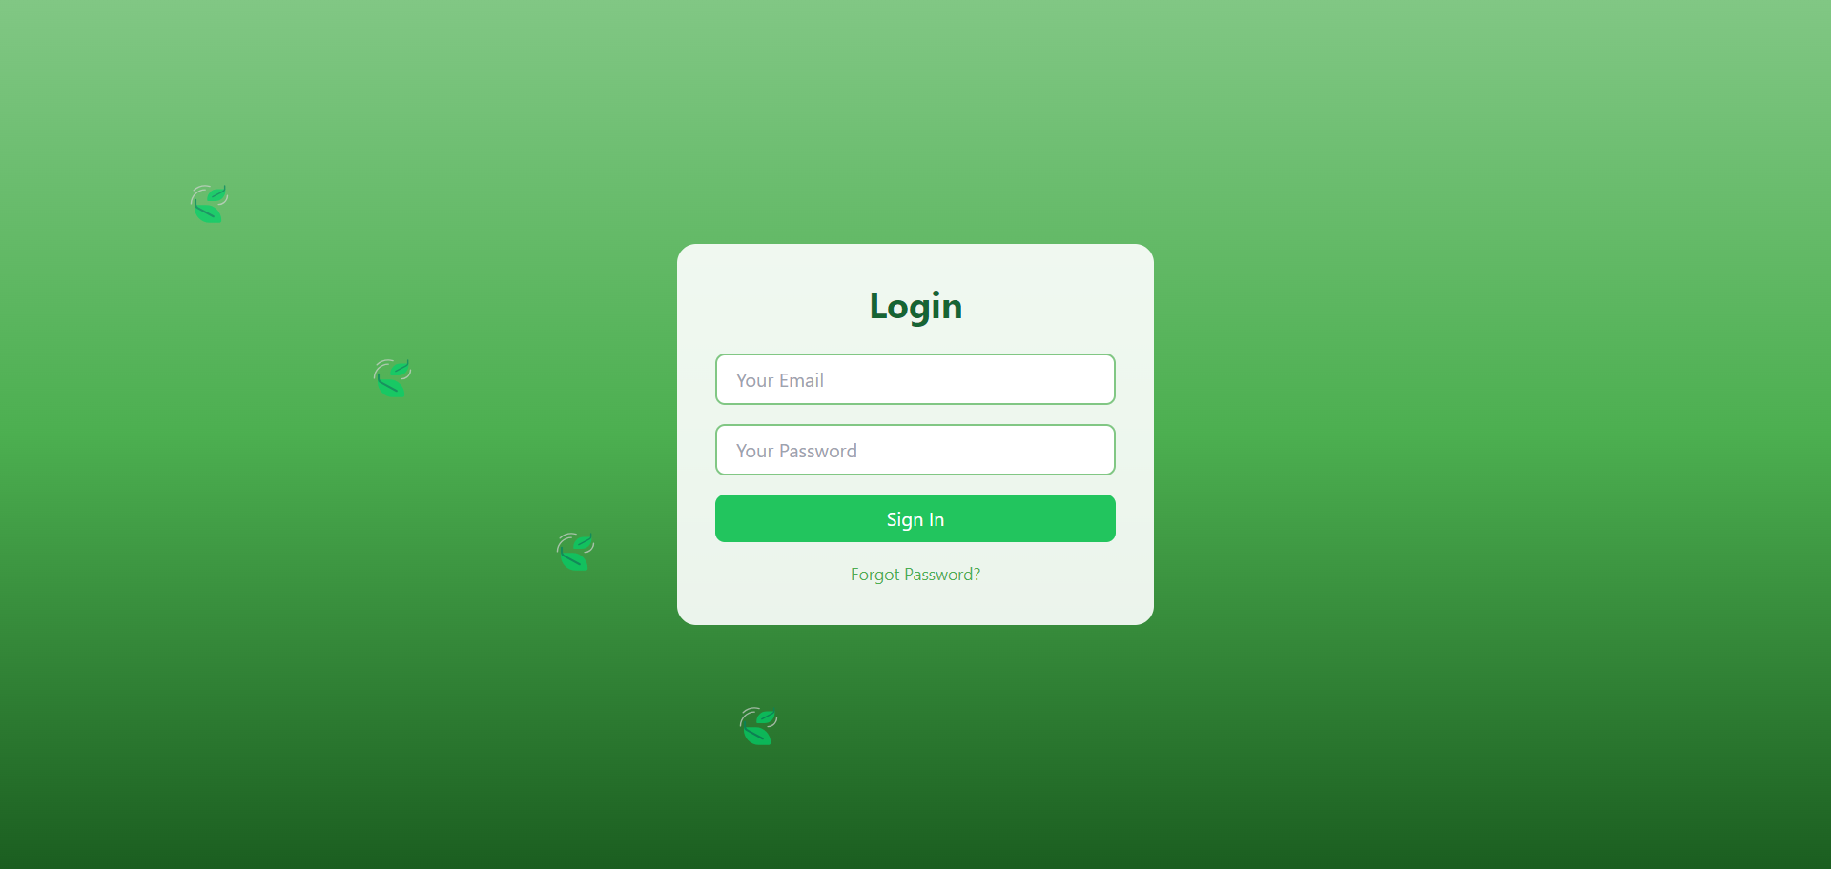

User Dashboard-

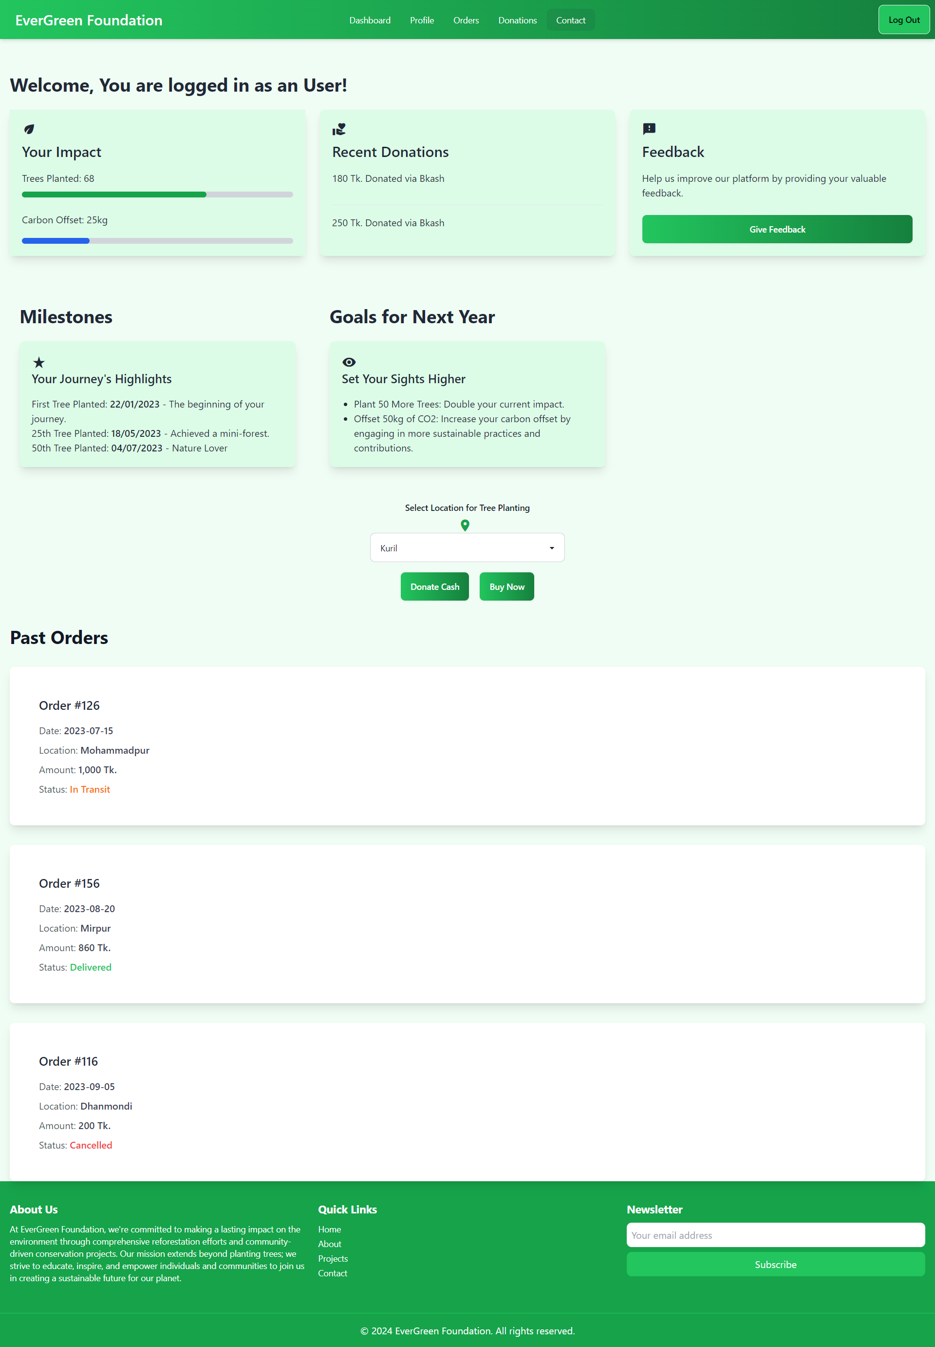

Volunteer Dashboard-

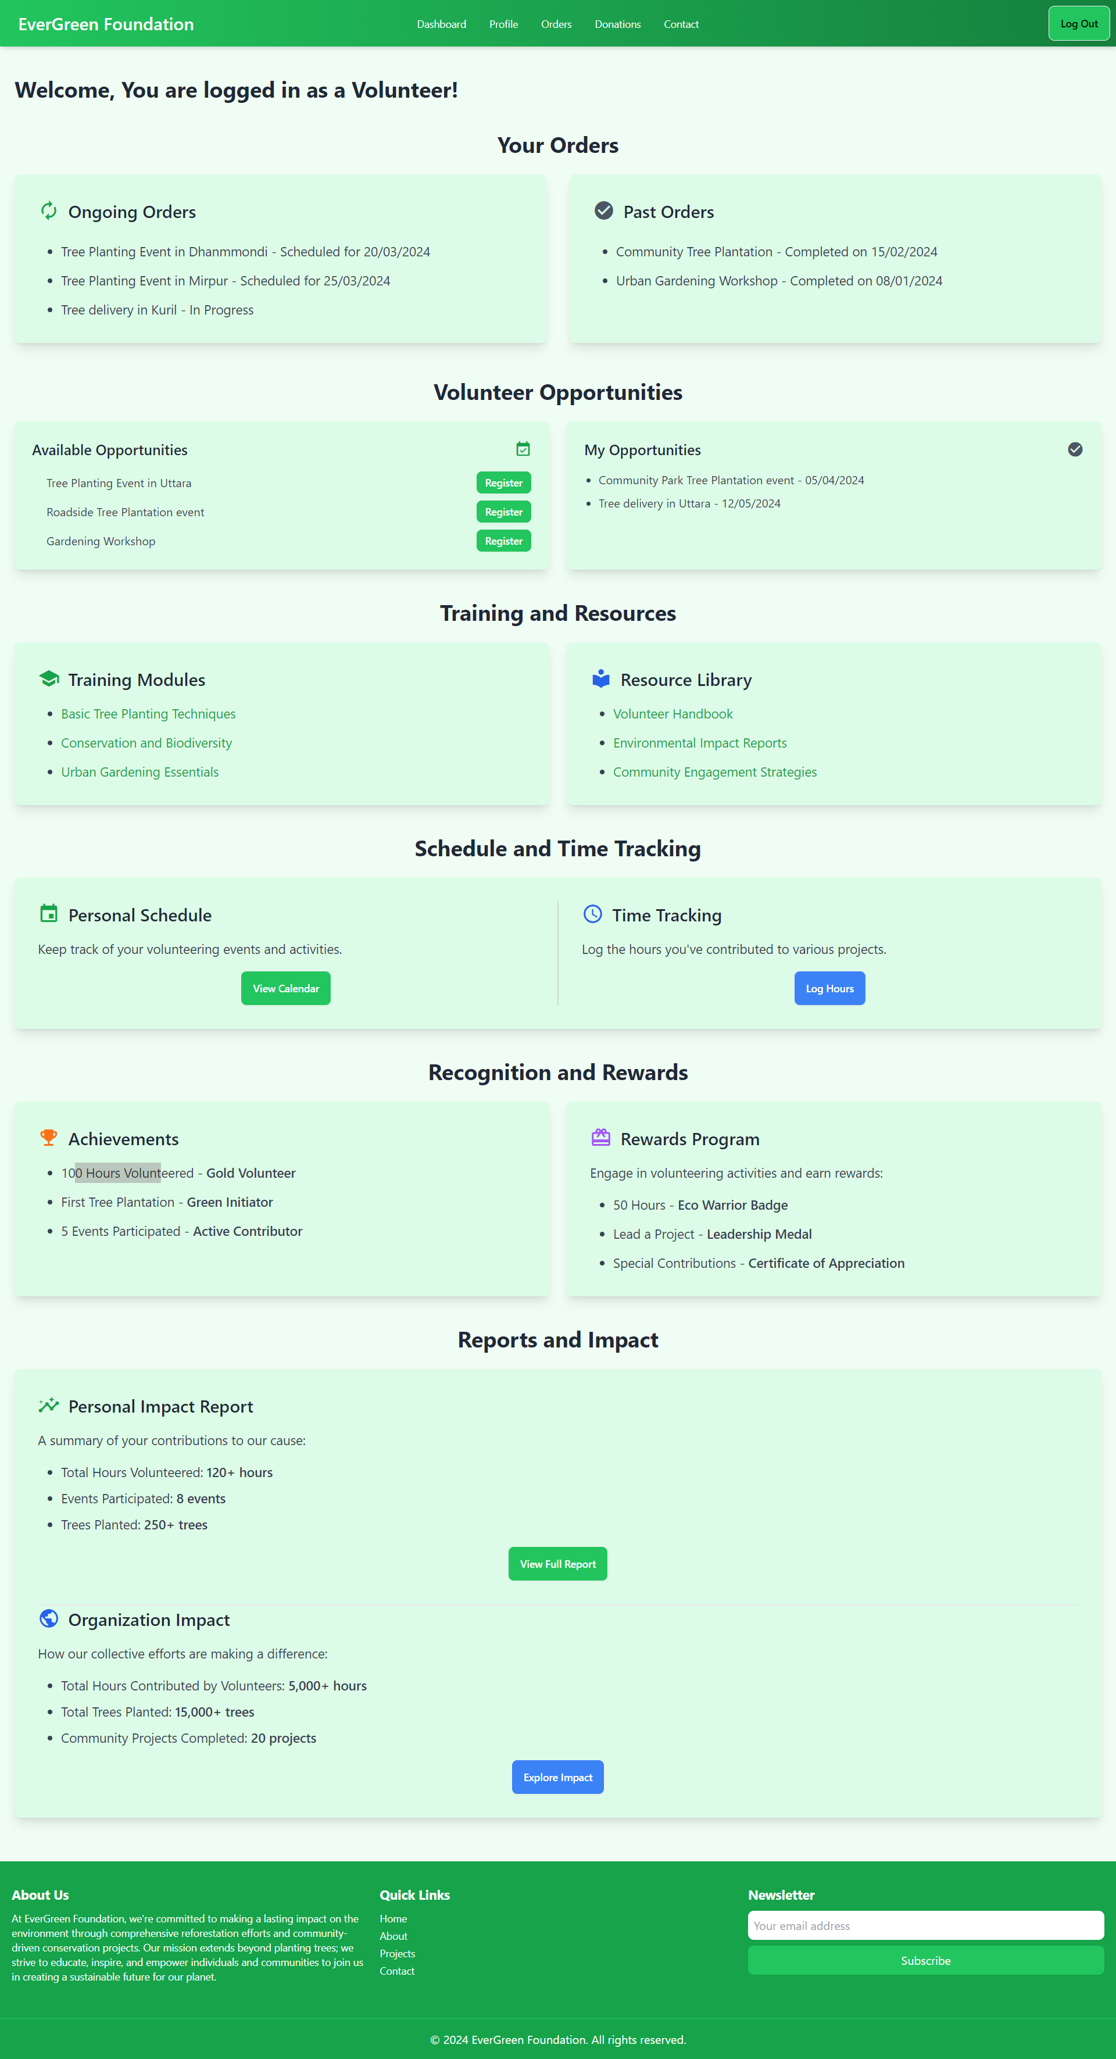

Main Webpage-

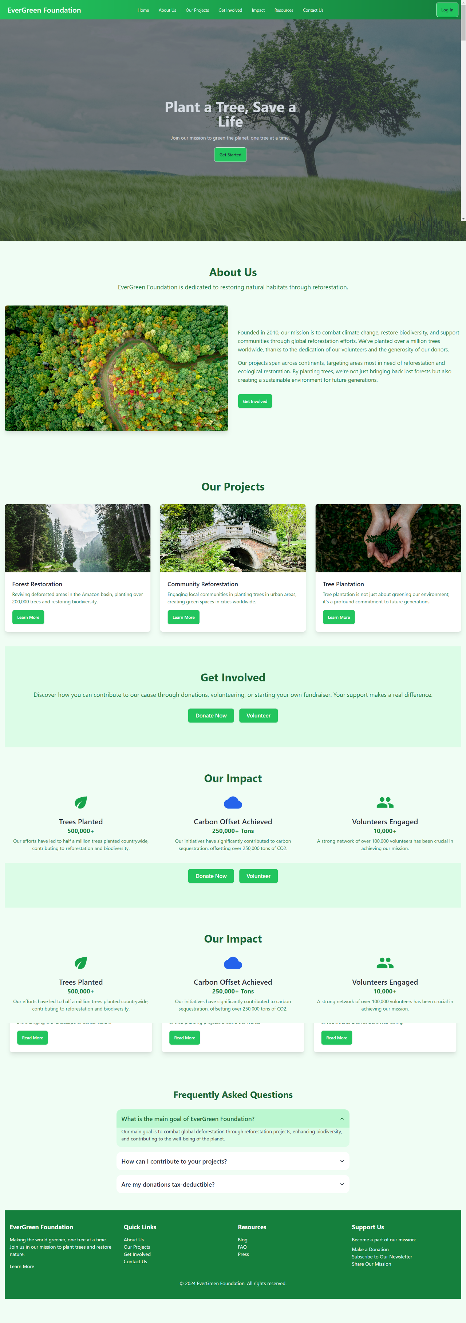

Donor Dashboard-

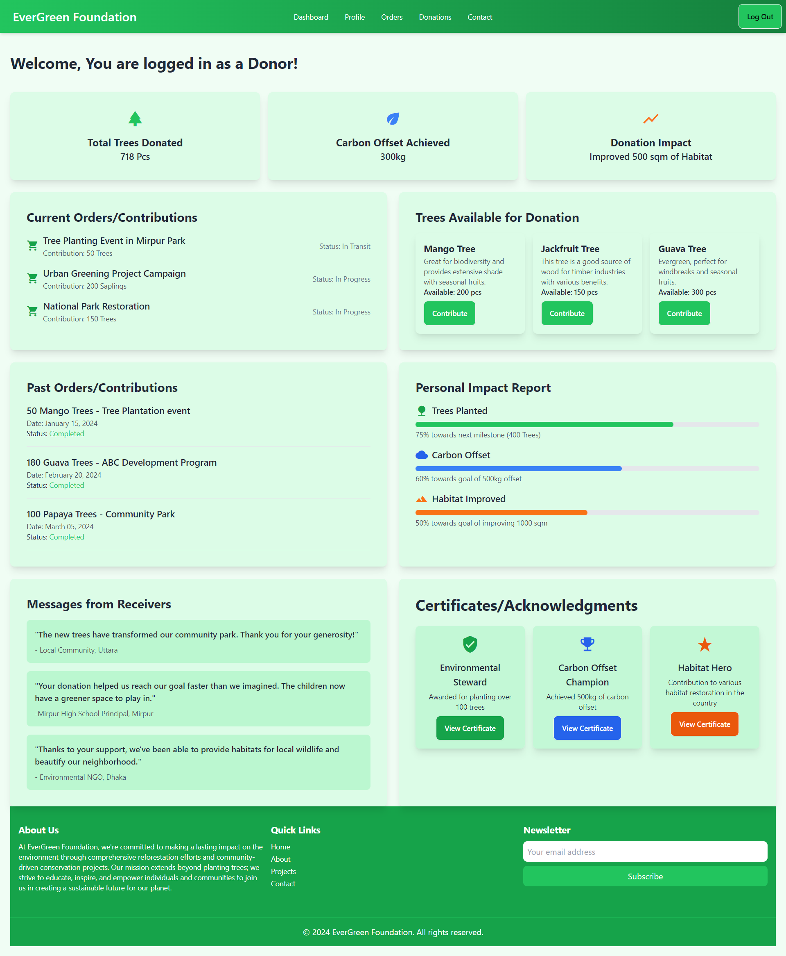

Admin Dashboard-

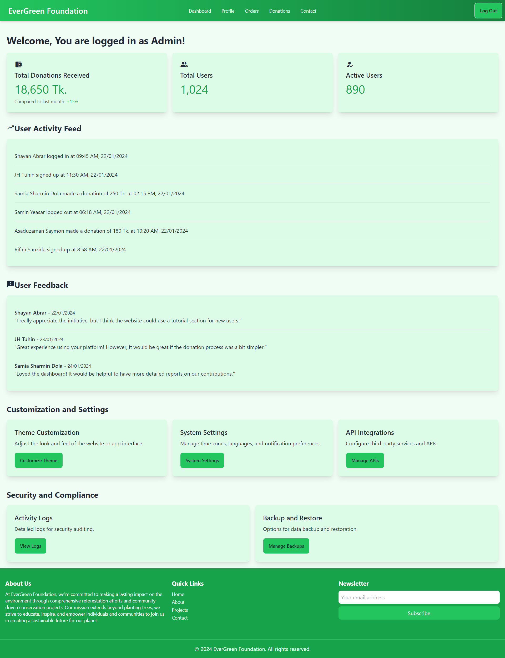

**For mobile:**

Login

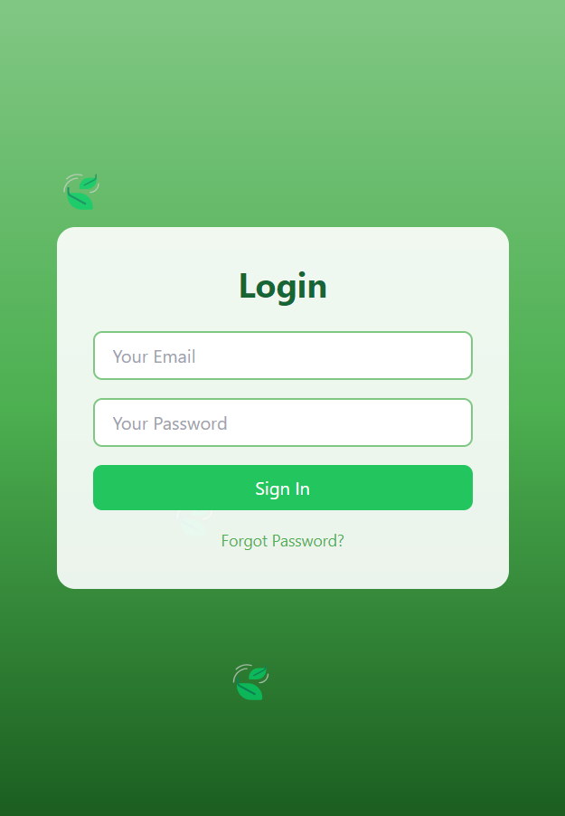

Admin Dashboard-

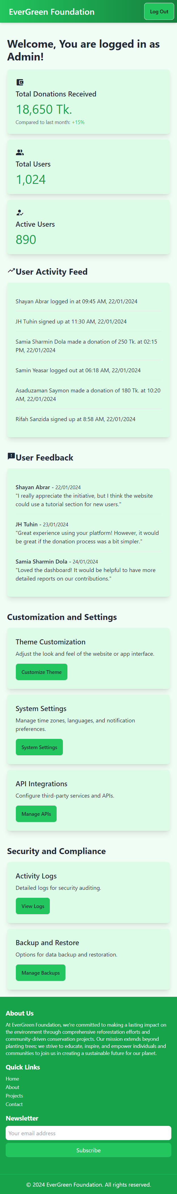

Main Webpage-



User Dashboard-

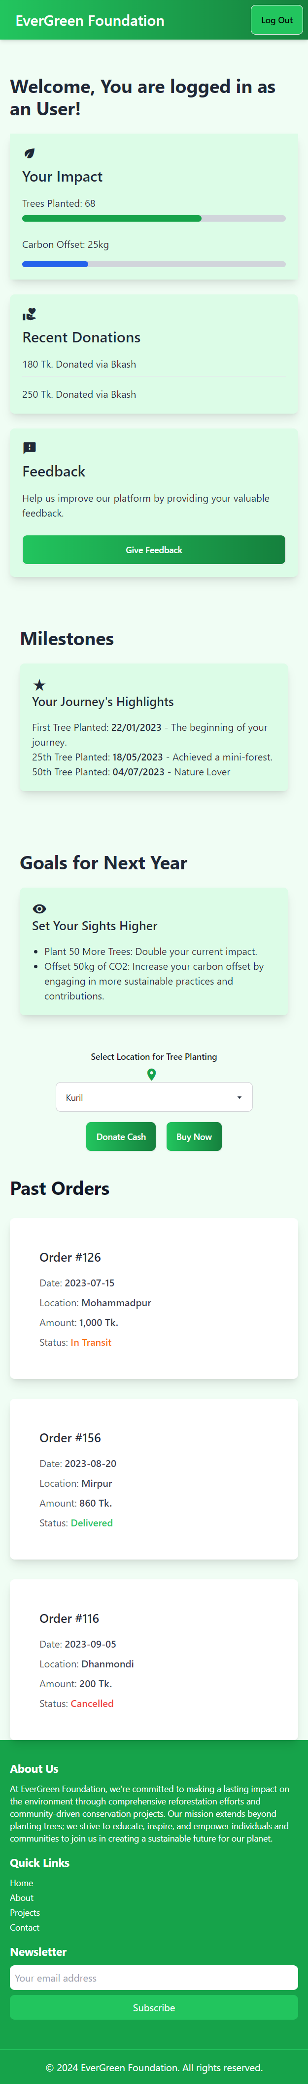

Donor Dashboard-

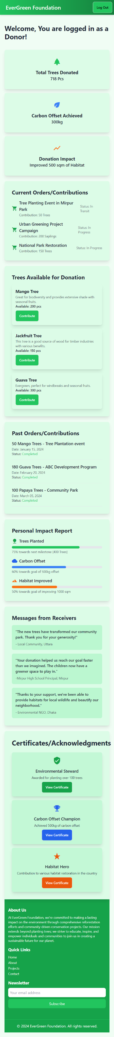

Volunteer Dashboard-

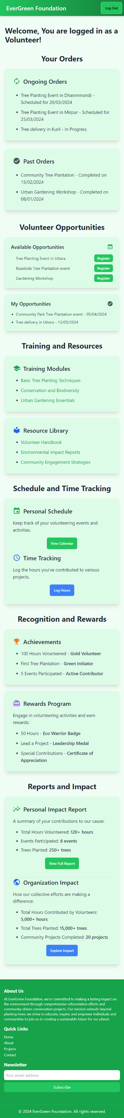

**Architectural diagram**

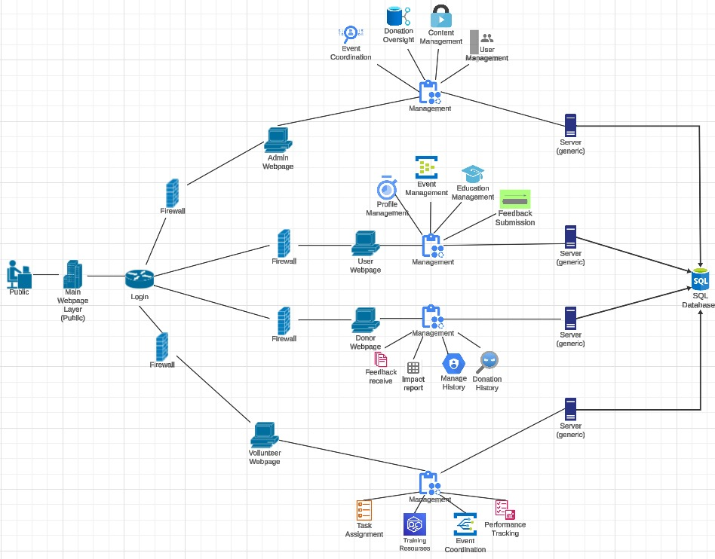

**Class diagram**

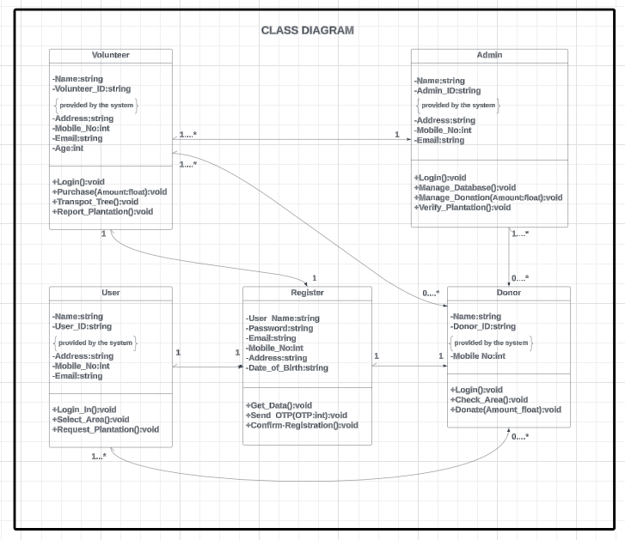

**Activity Diagram-**

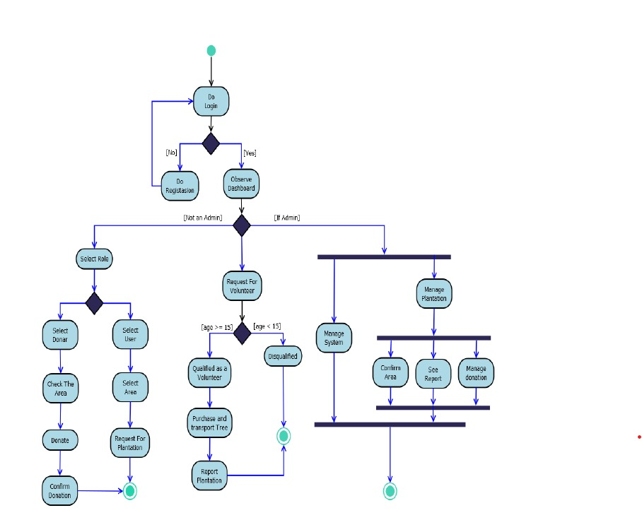

**Sequence Diagram:**

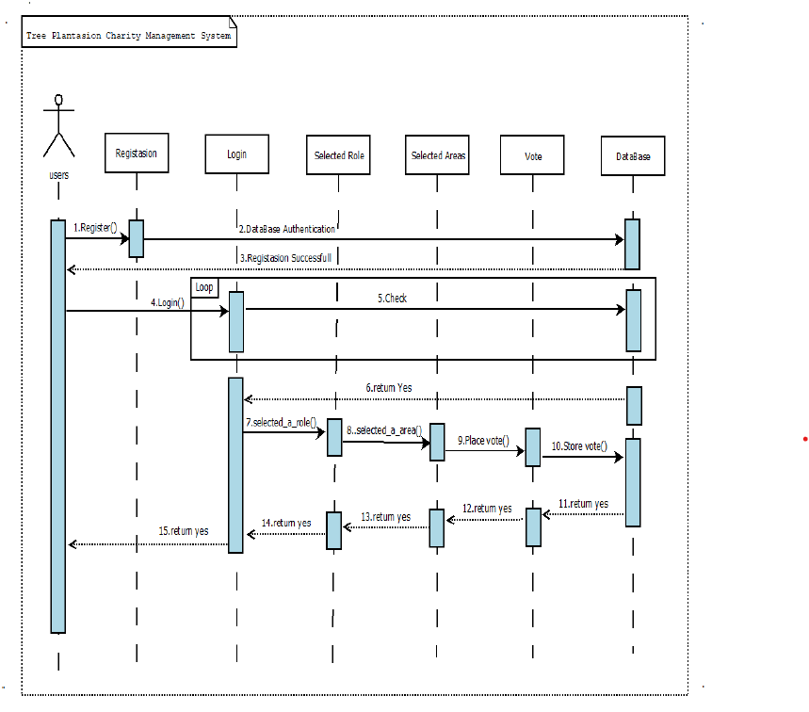

**Deployment diagram-**

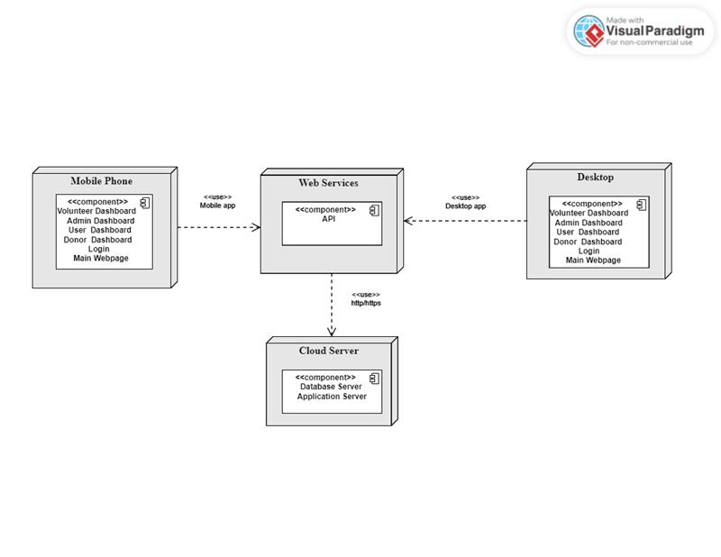

**Test/SQA Plan**

|  |  |  |  |  |  |
| --- | --- | --- | --- | --- | --- |
| **Test Case ID** | EVG_01 | **Test Case Description** | Test the Website Access and Navigation for EverGreen Foundation Website | | |
| **Created By** | Shayan Abrar | **Reviewed By** | DR. KAMRUDDIN MD. NUR | **Version** | 1.0 |

**QA Tester’s Log**

Review comments by Dr.Kamruddin incorporated in version 1.0

|  |  |  |  |  |  |
| --- | --- | --- | --- | --- | --- |
| **Tester's Name** | Shayan Abrar | **Date Tested** | 10-Apr-2024 | **Test Case (Pass/Fail/Not**  **Executed)** | Pass |

|  |  |
| --- | --- |
| **S #** | **Test Data** |
| 1 | www.EvergreenFoundation.com |
| 2 |  |
| 3 |  |
| 4 |  |

|  |  |
| --- | --- |
| **S #** | **Prerequisites:** |
| 1 | Access to a Chrome Browser |
| 2 | A stable internet connection |
| 3 |  |
| 4 |  |

**Test Scenario**

Verify that the main sections of the EverGreen Foundation's website are accessible and navigational elements function correctly.

|  |  |  |  |  |
| --- | --- | --- | --- | --- |
| **Step #** | **Step Details** | **Expected Results** | **Actual Results** | **Pass / Fail / Not executed / Suspended** |
| 1 | Open the Chrome browser and navigate to the EverGreen Foundation's website by entering the provided URL. | The homepage of the EverGreen Foundation should load successfully without errors. | As Expected | Pass |
| 2 | Verify the presence and functionality of the navigation bar, including links to Home, About Us, Our Projects, Get Involved, Impact, Resources, Contact Us, and Log In. | Each section in the navigation bar should be clickable, leading to the respective page or section without errors. | As Expected | Pass |
| 3 | Scroll down to the footer and verify the presence and functionality of footer links, including Quick Links, Resources, and Support Us. | Each link in the footer should be clickable and direct the user to the correct page or section as indicated. | As Expected | Pass |
| 4 | From the homepage, click on the "Log In" button and verify the page transition to the login page. | The login page should load successfully, displaying fields for email and password entry. | As Expected | Pass |
| 5 | On the login page, check for the presence of the "Forgot Password?" link and verify its functionality. | Clicking the "Forgot Password?" link should direct the user to a password reset page or prompt. | As Expected | Pass |
| 6 | Using the navigation bar, access the "About Us" section and verify that the content loads correctly and matches the expected information. | The "About Us" page should display detailed information about the EverGreen Foundation without loading issues. | As Expected | Pass |
| 7 | Access the "Contact Us" section through the navigation bar and verify the presence of a contact form or contact information. | The "Contact Us" page should include a form for inquiries or display contact information (email, phone number) of the EverGreen Foundation. | As Expected | Pass |
| 8 | Attempt to access the website using a different browser (e.g., Firefox, Safari) to verify cross-browser compatibility. | The website should load and function correctly across different browsers, with all navigational elements and links working as expected. | As Expected | Pass |

|  |  |  |  |  |  |
| --- | --- | --- | --- | --- | --- |
| **Test Case ID** | EVG_02 | **Test Case Description** | Test Login Form Functionality and Validation on EverGreen Foundation Website | | |
| **Created By** | Shayan Abrar | **Reviewed By** | DR. KAMRUDDIN MD. NUR | **Version** | 1.0 |

**QA Tester’s Log**

Review comments by Dr.Kamruddin incorporated in version 1.0

|  |  |  |  |  |  |
| --- | --- | --- | --- | --- | --- |
| **Tester's Name** | Shayan Abrar | **Date Tested** | 10-Apr-2024 | **Test Case (Pass/Fail/Not**  **Executed)** | Pass |

|  |  |
| --- | --- |
| **S #** | **Test Data** |
| 1 | Valid Email: [user@gmail.com](mailto:user@gmail.com),  vollunteer@gmail.com,  donor@gmail.com,  admin@gmail.com. |
| 2 | Password:123 |
| 3 |  |
| 4 |  |

|  |  |
| --- | --- |
| **S #** | **Prerequisites:** |
| 1 | Access to a Chrome Browser |
| 2 | User is on the EverGreen Foundation's Login form page |
| 3 |  |
| 4 |  |

**Test Scenario**

Verify that Login form field validations work as expected, forms can be submitted successfully, and data is handled properly.

|  |  |  |  |  |
| --- | --- | --- | --- | --- |
| **Step #** | **Step Details** | **Expected Results** | **Actual Results** | **Pass / Fail / Not executed / Suspended** |
| 1 | Navigate to the specific form page on the EverGreen Foundation website. | The form page loads successfully with all fields visible. | As Expected | Pass |
| 2 | Leave all fields blank and attempt to submit the form. | Validation messages appear indicating required fields. | As Expected | Pass |
| 3 | Enter an invalid email format in the email field and attempt to submit the form. | A validation message appears indicating the email is in an incorrect format. | As Expected | Pass |
| 4 | Fill out the form with all valid and required information except the email field. Use the invalid email format for this step. | The form submission should be blocked with a prompt to enter a valid email address. | As Expected | Pass |
| 5 | Correct the email field with a valid email address and fill in all other required fields correctly. Submit the form. | The form is submitted successfully. A success message appears or the user is redirected to a confirmation page. | As Expected | Pass |
| 6 | Verify the handling of the form data. This step may require backend access or confirmation from the system admin to ensure data is stored or processed as expected. | Form data is correctly handled as per the website's data handling protocol. | As Expected | Pass |
| 7 | Attempt to submit the form with valid data again but with the network disabled | An appropriate error message should appear, indicating the submission failed due to network issues. | As Expected | Pass |
| 8 | Re-enable the network and resubmit the form with valid information. | The form is submitted successfully, and the appropriate success message is shown. | As Expected | Pass |

|  |  |  |  |  |  |
| --- | --- | --- | --- | --- | --- |
| **Test Case ID** | EVG_03 | **Test Case Description** | Test the User Account Creation and Management functionalities, including Account Creation, Profile Editing, and Password Reset. | | |
| **Created By** | Shayan Abrar | **Reviewed By** | DR. KAMRUDDIN MD. NUR | **Version** | 1.0 |

**QA Tester’s Log**

Review comments by Dr.Kamruddin incorporated in version 1.0

|  |  |  |  |  |  |
| --- | --- | --- | --- | --- | --- |
| **Tester's Name** | Shayan Abrar | **Date Tested** | 10-Apr-2024 | **Test Case (Pass/Fail/Not**  **Executed)** | Pass |

|  |  |
| --- | --- |
| **S #** | **Test Data** |
| 1 | Valid Email: [user@gmail.com](mailto:user@gmail.com),  vollunteer@gmail.com,  donor@gmail.com,  admin@gmail.com. |
| 2 | Password:123 |
| 3 | New Password: 321 |
| 4 |  |

|  |  |
| --- | --- |
| **S #** | **Prerequisites:** |
| 1 | Access to a Chrome Browser |
| 2 | A stable internet connection |
| 3 |  |
| 4 |  |

**Test Scenario**

Verify the entire process of a user creating an account, updating their profile information, and successfully resetting their password on the EverGreen Foundation's website.

|  |  |  |  |  |
| --- | --- | --- | --- | --- |
| **Step #** | **Step Details** | **Expected Results** | **Actual Results** | **Pass / Fail / Not executed / Suspended** |
| 1 | Navigate to the EverGreen Foundation's website’s login page and locate the "Sign Up" or "Create Account" button. | User should be directed to the account creation page. | As Expected | Pass |
| 2 | Fill in all required fields, including a valid email address and a secure password. If there are optional fields, fill in at least one. | All fields accept input as expected. | As Expected | Pass |
| 3 | Submit the form and complete any email verification steps, if applicable. | User receives a verification email and successfully verifies the email address, completing the account creation process. | As Expected | Pass |
| 4 | Log in to the newly created account and navigate to the "Edit Profile" or "Account Settings" section. | User accesses the profile editing section successfully. | As Expected | Pass |
| 5 | Make changes to various fields, such as name, contact information, and any preferences available. Save the changes. | Changes are saved successfully without errors. | As Expected | Pass |
| 6 | Log out and log back in, verify that all changes have been retained. | All edited information persists after logging out and back in. | As Expected | Pass |
| 7 | Log out if currently logged in. Navigate to the login page and select the "Forgot Password?" link. | User is directed to the password reset request page. | As Expected | Pass |
| 8 | Enter the email address used for account creation and submit the request. | User receives a password reset email. | As Expected | Pass |
| 9 | Follow the instructions in the email to reset the password, creating a new password. | Password is successfully reset, and the user can log in with the new password. | As Expected | Pass |

|  |  |  |  |  |  |
| --- | --- | --- | --- | --- | --- |
| **Test Case ID** | EVG_04 | **Test Case Description** | Test Content Management System (CMS) functionalities for Admin, User, Volunteer, and Donor roles | | |
| **Created By** | Shayan Abrar | **Reviewed By** | DR. KAMRUDDIN MD. NUR | **Version** | 1.0 |

**QA Tester’s Log**

Review comments by Dr.Kamruddin incorporated in version 1.0

|  |  |  |  |  |  |
| --- | --- | --- | --- | --- | --- |
| **Tester's Name** | Shayan Abrar | **Date Tested** | 10-Apr-2024 | **Test Case (Pass/Fail/Not**  **Executed)** | Pass |

|  |  |
| --- | --- |
| **S #** | **Test Data** |
| 1 | Valid Email: [user@gmail.com](mailto:user@gmail.com),  vollunteer@gmail.com,  donor@gmail.com,  admin@gmail.com. |
| 2 | Password:123 |
| 3 |  |
| 4 |  |

|  |  |
| --- | --- |
| **S #** | **Prerequisites:** |
| 1 | Access to a Chrome Browser |
| 2 | A stable internet connection |
| 3 | Valid login credentials for each role |
| 4 |  |

**Test Scenario**

Verify CMS functionalities, including content updates and role-based permissions, are correctly implemented.

|  |  |  |  |  |  |
| --- | --- | --- | --- | --- | --- |
| **Step #** | **Roles** | **Step Details** | **Expected Results** | **Actual Results** | **Pass / Fail / Not executed / Suspended** |
| 1 | Admin | Log in as an Admin and attempt to update website content through the CMS. | Admin should be able to update content, and changes should be immediately reflected on the website. | As Expected | Pass |
| 2 | Admin | Verify Admin permissions to access and modify all sections of the CMS. | Admin should have permissions to access and modify content across all sections of the CMS. | As Expected | Pass |
| 3 | User | Log in as a User and try to access CMS functionalities. | User should have limited or no access to CMS functionalities, based on the website's permission settings. | As Expected | Pass |
| 4 | User | Attempt to navigate and use page-specific functionalities available to Users. | User should be able to freely use functionalities and view content specific to their role, without encountering permission errors. | As Expected | Pass |
| 5 | Volunteer | Log in as a Volunteer and access the CMS to update volunteer-related content, if applicable. | Volunteer should be able to update certain content related to volunteering activities, subject to permission settings. | As Expected | Pass |
| 6 | Volunteer | Navigate and utilize page buttons and functionalities specific to Volunteers. | Volunteer should navigate and use their specific page functionalities without issues. | As Expected | Pass |
| 7 | Donor | Log in as a Donor and attempt to access CMS functionalities, if applicable. | Donor should have permissions tailored to their role, potentially including donation history updates or profile editing. | As Expected | Pass |
| 8 | Donor | Test page navigation and role-specific functionalities for Donors. | Donor should be able to navigate their donation dashboard and use all functionalities without permission errors. | As Expected | Pass |

|  |  |  |  |  |  |
| --- | --- | --- | --- | --- | --- |
| **Test Case ID** | EVG_05 | **Test Case Description** | Test the Website's performance under varying conditions to ensure optimal load times and robustness under high traffic scenarios. | | |
| **Created By** | Shayan Abrar | **Reviewed By** | DR. KAMRUDDIN MD. NUR | **Version** | 1.0 |

**QA Tester’s Log**

Review comments by Dr.Kamruddin incorporated in version 1.0

|  |  |  |  |  |  |
| --- | --- | --- | --- | --- | --- |
| **Tester's Name** | Shayan Abrar | **Date Tested** | 10-Apr-2024 | **Test Case (Pass/Fail/Not**  **Executed)** | Pass |

|  |  |
| --- | --- |
| **S #** | **Test Data** |
| 1 | URLs for testing: Every roles dashboard including homepage and login page |
| 2 | Credentials for login simulation. |
| 3 | Data for form submissions (e.g., donations, applications). |
| 4 |  |

|  |  |
| --- | --- |
| **S #** | **Prerequisites:** |
| 1 | Access to Google PageSpeed Insights and JMeter. |
| 2 | A stable internet connection |
| 3 | Test every roles accounts and sample form data. |
| 4 |  |

**Test Scenario**

Verify page load times and website behavior under high traffic across multiple pages including login and image-heavy pages.

|  |  |  |  |  |
| --- | --- | --- | --- | --- |
| **Step #** | **Step Details** | **Expected Results** | **Actual Results** | **Pass / Fail / Not executed / Suspended** |
| 1 | **Load Time Test - Home Page:** Use performance testing tools like Google PageSpeed Insights to measure the load time of the website's home page. | The home page should load in under 3 seconds for users on a standard broadband connection.. | As Expected | Pass |
| 2 | **Load Time Test – Every role’s Dashboard:** Measure the load time of the User Dashboard page after login using the same tool. | The Dashboard pages should load in under 3 seconds for authenticated users on a standard broadband connection. | As Expected | Pass |
| 3 | **Stress Testing - Simultaneous Logins:** Utilize a tool like JMeter to simulate multiple users (e.g., 500 users) attempting to log in simultaneously. | The website should handle simultaneous login attempts without significant delays or errors, maintaining a response time under 5 seconds for each user. | As Expected | Pass |
| 4 | **Stress Testing - High Traffic Navigation:** Simulate high traffic navigating through various pages of the website (e.g., Home, About Us, Volunteer Sign-up) to determine site behavior under load. | Page navigation under high traffic should not significantly increase load times, aiming to keep page responses under 5 seconds. | As Expected | Pass |
| 5 | **Load Time Test - Image Heavy Page:** Measure the load time of any image-heavy pages, such as the gallery or project pages, using PageSpeed Insights. | Image-heavy pages should employ lazy loading techniques and optimized images to maintain a load time under 5 seconds. | As Expected | Pass |
| 6 | **Stress Testing - Data Submission:** Use automation tools to simulate the submission of data (e.g., donation forms, volunteer applications) by a large number of users concurrently. | The website should process data submissions without errors or significant delays, with form submission response times remaining under 5 seconds. | As Expected | Pass |
| 7 | **Stress Testing - Database Load:** Assess how the website's backend database handles queries under high load (e.g., retrieving user information, donation records). | Database queries should remain efficient under stress, with query response times not exceeding 2 seconds even under high load. | As Expected | Pass |
| 8 | **Load Time Test - Mobile Performance:** Evaluate the website's load time on mobile devices using a tool like Google's Mobile-Friendly Test or PageSpeed Insights for mobile. | The website should be optimized for mobile users, maintaining a load time of under 4 seconds on standard mobile connections. | As Expected | Pass |

|  |  |  |  |  |  |
| --- | --- | --- | --- | --- | --- |
| **Test Case ID** | EVG_06 | **Test Case Description** | Ensure the website supports keyboard shortcuts and complies with website-making rules and guidelines | | |
| **Created By** | Shayan Abrar | **Reviewed By** | DR. KAMRUDDIN MD. NUR | **Version** | 1.0 |

**QA Tester’s Log**

Review comments by Dr.Kamruddin incorporated in version 1.0

|  |  |  |  |  |  |
| --- | --- | --- | --- | --- | --- |
| **Tester's Name** | Shayan Abrar | **Date Tested** | 10-Apr-2024 | **Test Case (Pass/Fail/Not**  **Executed)** | Pass |

|  |  |
| --- | --- |
| **S #** | **Test Data** |
| 1 | List of expected keyboard shortcuts and their functions |
| 2 |  |
| 3 |  |
| 4 |  |

|  |  |
| --- | --- |
| **S #** | **Prerequisites:** |
| 1 | Access to a Chrome Browser |
| 2 | A stable internet connection |
| 3 | Knowledge of standard keyboard shortcuts for web navigation (e.g., Tab, Shift + Tab, Enter) |
| 4 |  |

**Test Scenario**

Verify that the EverGreen Foundation's website is accessible via keyboard shortcuts and complies with essential web accessibility standards.

|  |  |  |  |  |
| --- | --- | --- | --- | --- |
| **Step #** | **Step Details** | **Expected Results** | **Actual Results** | **Pass / Fail / Not executed / Suspended** |
| 1 | Navigate to the EverGreen Foundation's website using the Chrome browser. Use the **Tab** key to move through interactive elements on the homepage. | Users should be able to navigate through all interactive elements (links, buttons) in a logical order. | As Expected | Pass |
| 2 | While navigating, use **Shift + Tab** to move backwards through interactive elements. | The focus should move in the reverse order, allowing users to navigate back through elements. | As Expected | Pass |
| 3 | Use the **Enter** key to select links or buttons that are currently focused. | The appropriate action for the focused element (e.g., link navigation, button activation) should occur.. | As Expected | Pass |
| 4 | On pages with forms (e.g., the login or contact page), use **Tab** to move between form fields, and use **Enter** to submit the form. | Users should be able to fill out and submit forms using only the keyboard. | As Expected | Pass |
| 5 | Test any custom keyboard shortcuts documented for the website, if available, to perform specific actions. | Custom shortcuts should perform their expected functions correctly. | As Expected | Pass |
| 6 | Use accessibility testing tools (e.g., WAVE, AXE) to analyze the website for compliance with Web Content Accessibility Guidelines (WCAG) guidelines. | The tool should report minimal to no accessibility issues, indicating compliance with WCAG standards. | As Expected | Pass |
| 7 | Verify the website’s functionality without the use of a mouse, ensuring all actions can be completed using the keyboard alone. | All website functionalities (navigation, form submission, page access) should be fully operable via keyboard. | As Expected | Pass |

|  |  |  |  |  |  |
| --- | --- | --- | --- | --- | --- |
| **Test Case ID** | EVG_07 | **Test Case Description** | Test the Website's Responsive Design Across Multiple Devices | | |
| **Created By** | Shayan Abrar | **Reviewed By** | DR. KAMRUDDIN MD. NUR | **Version** | 1.0 |

**QA Tester’s Log**

Review comments by Dr.Kamruddin incorporated in version 1.0

|  |  |  |  |  |  |
| --- | --- | --- | --- | --- | --- |
| **Tester's Name** | Shayan Abrar | **Date Tested** | 10-Apr-2024 | **Test Case (Pass/Fail/Not**  **Executed)** | Pass |

|  |  |
| --- | --- |
| **S #** | **Test Data** |
| 1 | Devices: Mobile (Portrait & Landscape), Tablet (Portrait & Landscape), Desktop. |
| 2 | Browsers: Chrome, Firefox, Safari. |
| 3 |  |
| 4 |  |

|  |  |
| --- | --- |
| **S #** | **Prerequisites:** |
| 1 | Access to multiple devices (mobile, tablet, desktop) or a responsive design testing tool. |
| 2 |  |
| 3 |  |
| 4 |  |

**Test Scenario**

Ensure the website provides a seamless experience across all screen sizes, with specific attention to mobile and tablet compatibility and layout breakpoints.

|  |  |  |  |  |
| --- | --- | --- | --- | --- |
| **Step #** | **Step Details** | **Expected Results** | **Actual Results** | **Pass / Fail / Not executed / Suspended** |
| 1 | Test the website on a mobile device in portrait mode. | The website should scale correctly, with all elements visible and functional without the need to horizontally scroll. | As Expected | Pass |
| 2 | Test the website on a mobile device in landscape mode. | The website should adjust to the wider view, improving readability and interaction without layout issues. | As Expected | Pass |
| 3 | Test the website on a tablet device in portrait mode.. | The layout adjusts to utilize the available screen space effectively, with a balanced distribution of content and navigational elements.. | As Expected | Pass |
| 4 | Test the website on a tablet device in landscape mode. | The website should offer an optimized experience that leverages the additional width, potentially showing more content or a different layout structure. | As Expected | Pass |
| 5 | Test the website on a desktop browser. Gradually reduce the browser window width. | The website should hit several layout breakpoints, where the design adjusts to accommodate the new viewport size without breaking the layout or hiding necessary information. | As Expected | Pass |
| 6 | Verify the functionality of dropdown menus, buttons, and links at various screen sizes. | All interactive elements should function correctly, with touch-friendly sizes on smaller screens. | As Expected | Pass |
| 7 | Test form elements (like the login form) on all devices to ensure they are usable. | Forms should be easy to fill out, with appropriately sized fields and clear, accessible labels and instructions. | As Expected | Pass |
| 8 | Test images and multimedia content for proper scaling and performance. | Images and videos should scale correctly without distortion, and not significantly impact the page load times on mobile networks. | As Expected | Pass |
| 9 | Test the website's navigation on all device types to ensure it remains intuitive and accessible. | Navigation should adjust for the device, possibly shifting to a hamburger menu on smaller screens, allowing users to easily navigate the site. | As Expected | Pass |
| 10 | Test the readability of text content across devices. | Text should be legible without needing to zoom in, with appropriate font sizes and line spacing for comfortable reading on small screens. | As Expected | Pass |

Our Test/SQA (Software Quality Assurance) Plan outlines the strategies and procedures for ensuring the quality and reliability of our website throughout its development lifecycle. By implementing comprehensive testing practices, we aim to identify and resolve defects, optimize performance, and deliver a seamless user experience.

**Objectives:**

**Ensure Functionality:** Verify that all website features and functionalities perform as intended according to specified requirements.

**Validate Usability:** Assess the user interface (UI) and user experience (UX) design to ensure ease of navigation, accessibility, and user satisfaction.

**Ensure Security:** Identify and mitigate potential security vulnerabilities to safeguard user data and protect against cyber threats.

**Optimize Performance:** Evaluate the website's performance metrics, including speed, responsiveness, and scalability, to deliver optimal user experiences across devices and network conditions.

**Validate Compatibility:** Test the website across various browsers, devices, and operating systems to ensure consistent performance and compatibility.

**Verify Compliance:** Ensure compliance with relevant standards, regulations, and best practices related to web development, data privacy, and accessibility.  
  
**Testing Approach:**

**Unit Testing:** Developers conduct unit tests to validate individual components and functions, ensuring they operate correctly in isolation.

**Integration Testing:** Testers verify the interaction and integration of different modules or components to ensure seamless communication and data flow.

**System Testing:** Validate the overall functionality and behavior of the website as a complete system, including user interactions, data processing, and error handling.

**User Acceptance Testing (UAT):** Involve end-users or stakeholders to evaluate the website's usability, functionality, and alignment with their needs and expectations.

**Security Testing:** Conduct penetration testing, vulnerability assessments, and security audits to identify and address potential security vulnerabilities and weaknesses.

**Performance Testing:** Evaluate the website's performance under various conditions, including load testing, stress testing, and scalability testing, to ensure optimal performance and responsiveness.

**Compatibility Testing:** Test the website's compatibility across different browsers, devices, and platforms to ensure consistent behavior and user experience.

**Accessibility Testing:** Assess the website's compliance with accessibility standards (e.g., WCAG) to ensure inclusivity and accessibility for users with disabilities.  
  
**Testing Tools and Techniques:**

**Automated Testing:** Utilize automated testing tools and frameworks (e.g., Selenium, Cypress) to streamline testing processes and accelerate test execution.

**Manual Testing:** Conduct manual testing by human testers to validate subjective aspects such as usability, visual design, and content accuracy.

**Security Scanning Tools:** Employ security scanning tools (e.g., OWASP ZAP, Burp Suite) to identify and address security vulnerabilities, including SQL injection, cross-site scripting (XSS), and CSRF.

**Performance Monitoring Tools:** Use performance monitoring tools (e.g., Google Lighthouse, WebPageTest) to assess and optimize website performance metrics, including page load times, resource utilization, and rendering performance.

**Test Documentation:**

**Test Cases:** Develop comprehensive test cases covering all functional requirements, edge cases, and user scenarios to guide testing activities.

**Test Scripts:** Create automated test scripts to automate repetitive test cases and streamline regression testing processes.

**Test Reports:** Generate test reports documenting test results, including defects identified, test coverage, and performance metrics, to facilitate decision-making and issue resolution.

By adhering to the Test/SQA Plan and implementing rigorous testing practices, we ensure the delivery of a high-quality website that meets user expectations, complies with security standards, and delivers exceptional user experiences across all dimensions.

**Maintenance Plan**

The Maintenance Plan outlines the strategies and procedures for ensuring the ongoing functionality, stability, and sustainability of our website following its deployment. It encompasses activities aimed at addressing issues, implementing updates, and enhancing the website to meet evolving user needs and technological advancements.

**Objectives:**

**Address Issues Promptly:** Establish a system for identifying and addressing bugs, errors, and performance issues promptly to minimize disruptions and maintain user satisfaction.

**Implement Updates:** Regularly update the website to incorporate new features, enhancements, security patches, and bug fixes to improve functionality and address emerging threats.

**Enhance User Experience:** Continuously evaluate user feedback and analytics data to identify areas for improvement and implement enhancements to optimize the user experience.

**Ensure Compatibility:** Monitor and ensure compatibility with evolving web standards, browsers, devices, and operating systems to maintain consistent performance across platforms.

**Optimize Performance:** Monitor and optimize website performance metrics, including speed, responsiveness, and scalability, to ensure optimal user experiences and mitigate performance degradation.

**Ensure Security:** Implement security measures, updates, and best practices to protect against evolving cybersecurity threats and vulnerabilities and safeguard user data.

**Maintenance Approach:**

**Issue Tracking and Resolution:** Utilize issue tracking systems and workflows to efficiently manage and prioritize reported issues, track resolutions, and communicate updates with stakeholders.

**Scheduled Updates:** Implement a schedule for regular updates and maintenance activities, including software patches, security updates, and feature enhancements, to ensure the website remains current and secure.

**User Feedback Integration:** Establish channels for collecting user feedback, suggestions, and bug reports and incorporate them into the maintenance process to address user needs and improve satisfaction.

**Proactive Monitoring:** Implement monitoring tools and processes to proactively identify performance issues, security vulnerabilities, and potential system failures and take preemptive actions to mitigate risks.

**Regression Testing:** Conduct regression testing after updates and changes to ensure that existing functionalities remain intact and new features do not introduce unintended consequences or regressions.

**Backup and Disaster Recovery:** Implement robust backup and disaster recovery strategies to safeguard against data loss, system failures, or cyber attacks and ensure business continuity in the event of unforeseen incidents.

**Maintenance Documentation:**

**Change Logs:** Maintain detailed change logs documenting all updates, modifications, and enhancements made to the website, including the rationale behind each change and its impact on functionality.

**Maintenance Records:** Keep records of maintenance activities, including issue reports, resolutions, update schedules, and performance metrics, to track progress, measure effectiveness, and inform future maintenance efforts.

**User Communications:** Communicate maintenance schedules, updates, and important announcements to users and stakeholders through newsletters, notifications, or dedicated communication channels to manage expectations and minimize disruptions.

By implementing a proactive and comprehensive Maintenance Plan, we ensure the continued reliability, functionality, and security of our website, enabling us to deliver value to users, adapt to changing requirements, and sustain long-term success in the digital landscape.  
  
  
**Conclusion:**

In conclusion, our project aims to create a user-friendly software for the EverGreen Foundation, facilitating donations, promoting environmental awareness, and fostering community engagement. By providing easy access to information, donation opportunities, and impactful stories, we strive to inspire individuals to contribute to reforestation efforts and conservation projects. Anticipating increased donor participation, improved user experiences, and greater environmental impact, our project endeavors to make a meaningful difference in preserving our planet for future generations. Through collaborative efforts and ongoing maintenance, we are committed to ensuring the sustainability and success of our software, driving positive change and empowering individuals to join us in creating a greener, healthier world.